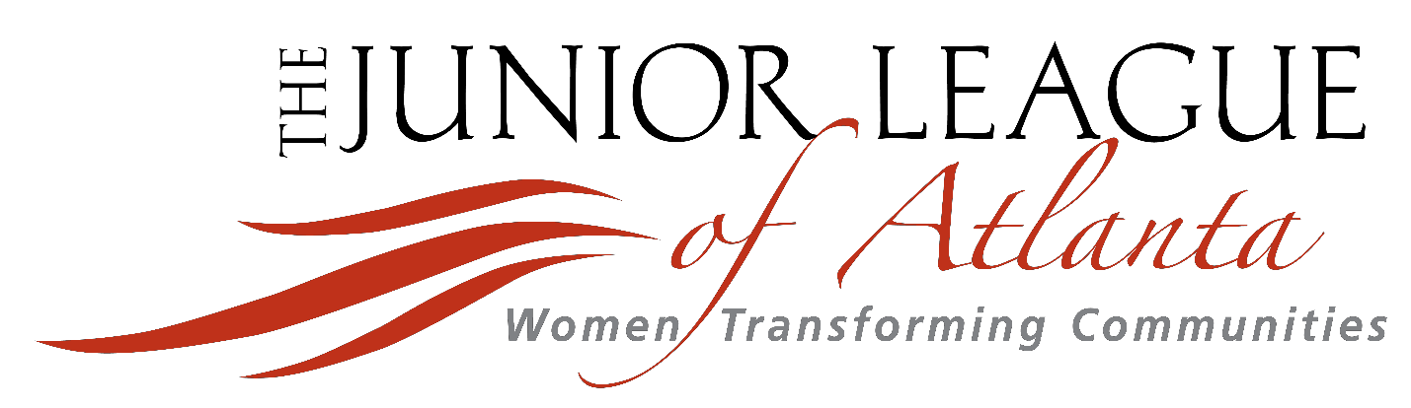

Joining The Junior League of Atlanta, Inc.
2021 Prospective Member Packet

Table of Contents

JLA Recruitment Committee Contact......................................................................................... 2

2021 - 2022 Provisional Year Requirements.............................................................................. 3

FAQs About Your Provisional Year............................................................................................ 5

Helpful Links to Learn More About JLA.................................................................................... 10

JLA Membership Spotlights..................................................................................................... 11

The Junior League of Atlanta, Inc., is an organization of women committed to promoting voluntarism, developing the potential of women, and improving the community through the effective action and leadership of trained volunteers. Its purpose is exclusively educational and charitable.
JLA Recruitment Committee Contacts

Makina Wallace, Director-Elect of Member Recruitment & Outreach
Delonee McBride, Director of Member Recruitment & Outreach recruitment@jlatlanta.org

JLA Headquarters Staff info@jlatlanta.org
404-261-7799

Carrie Kolkebeck, Director-Elect, Provisional Development
JLAProvisionals@jlatlanta.org

2021- 2022 Provisional Year Requirements
*Tentative and Subject to Change
Obligations
(see explanations below the chart) Required

Application Fee (April 24, 2021
Deadline) $25
2021-2022 Dues + Course Fee (Due
May 15, 2021) $355 ($230 + $125)

Orientation Must attend 1, 2 offered

Education Courses Must attend 2 out of 3 courses
(each course offered twice for total of 6)

Small Group Meetings Must attend 4, 6 offered

Provisional Bus Tour Must attend 1, 1 offered

General Membership Meeting (GMM) Must attend 1, 3 offered

Membership Credit

Examples
• District Meeting Credit
• Expo Meeting Credit
• Fundamental Meeting Credit
• Fundraiser Credit

Must attend 3, multiple offered

2022-2023 Dues (Due March 1, 2022) $230

Application Fee

** Final schedule will be provided during Orientation **
Non-refundable fee paid as part of the application process.

2021-2022 Dues + Course Fee (Due May 15, 2021)
Your membership dues and the one-time Provisional course fee are to be paid by May 15,
2021.

Continued…

Orientation*
This event will give you an overview of everything that is in store for the Provisional year, as well as give you the foundational knowledge needed to successfully navigate your JLA
membership. You will have ample opportunity to ask questions about any part of the
Provisional program. You will also be matched with your small group at this event.

Education Courses
Your education courses will provide you a better foundation on the JLA cornerstones, or traits the League has deemed important to be a great servant leader. There will be three courses offered, each on a different topic, throughout the year. Each course will be offered twice, once on a weekday and once on a weekend, for a total of 6 sessions offered. You will need to attend two out of the three courses offered.

Small Group Meetings
You will be put into a small group once you begin your Provisional year. Your small group is typically made up of between 15-20 other Provisionals who are around the same age as you. Each group will have a Provisional advisor. This advisor will host at least four gatherings for you and your group throughout the year. These gatherings are mainly social, but still provide a way for the advisor to answer any League questions you may have, and are a great way to get to know other Provisionals in a much smaller setting. Examples of small group gatherings include going out to dinner, carving pumpkins for Halloween, volunteering at one of our community partners, or pottery painting. Small groups will be offered once a month September thru December and twice during the Spring for a total of 6 opportunities. You will need to attend at least four small group meetings.

Provisional Bus Tour*
One of the highlights of the Provisional program is the Provisional bus tour. It’s one thing to hear about our community partners, but it’s another to actually go out and see them for yourself! This bus tour will allow you the chance to visit some of our community partners to see how the League makes an impact through partnerships. Past stops on the tour have included Chastain Horse Park, Kate’s Club, Atlanta Community Food Bank, and Meals on Wheels Atlanta. Please note, there will only be one tour date offered, so please try your best to attend.

General Membership Meeting (GMM)
General Membership Meetings, also known as GMMs, are meetings held for all members of JLA. GMMs educate JLA members on community issues and the League’s strategic volunteer impact by featuring prominent community leaders, showcasing community, fundraising & advocacy projects, and increasing the volunteer leadership skills of JLA members through service opportunities. Typically, three GMM meetings are offered throughout the year. You will only need to attend one.

Membership Credit
There are a variety of ways to meet the required 3 membership credits, and these events are opportunities to meet women in the League outside the Provisional class. You are welcome to attend as many events as you want, but please note that you only need to get three credits.

Continued…
Some options include:

• District Meetings - In addition to a small group, you will also be assigned a district group based on where you live in the city. Your District will include women of all ages and experience levels within the League.

• Placement Expo - The Placement Expo is an opportunity in the Spring to learn about all the JLA Community Placements for the following year. This event will help guide your decision about what Community Placement you want for your First Year Active.

• Fundamental Courses - These are quick, 2-hour sessions offered throughout the year that provide information on a variety of topics that will benefit current members in their everyday lives. Topics can be anything from how to better your overall health to how to better serve on a nonprofit board.

• Fundraisers - We have three great fundraisers that the League does every year: Little Black Dress Initiative, Shamrock N’Roll, and Tour of Kitchens. There will be opportunities to volunteer or participate in one of these fundraisers to receive membership credit.

• JLA Serves - This event happens two weekends a month. Our membership goes out into the community to complete service projects that can be completed in a day.

2022-2023 Dues (Due March 1, 2022)
Dues for all JLA membership levels are due March 1 to cover their membership for the following
League Year from June 2022 – May 2023. This will be paid to cover your First Active Year.

*For requirements with only one offered, please reach out to your Provisional Small Group Advisor if you have a conflict and cannot attend. She and the Provisional Development Director will work with you from there.
Frequently Asked Questions: About Your Provisional Year

What will my Provisional year look like?
The Provisional year is purposefully designed to introduce and educate you on The Junior League of Atlanta, Inc. while providing opportunities to socialize, create new connections, gain access to valuable training, learn about our mission and community impact, and serve with our community agencies and programs.

What does the application process look like?
All a potential Provisional member needs to do is
1) create a profile
2) pay the $25 application fee
3) spend 10-15 minutes completing the application form
4) wait for her application to be reviewed
5) receive notification of acceptance
6) paid dues and the Provisional course fee

Do I need a Sponsor?
No! Other Junior Leagues around the world require a ‘sponsor,’ or a current member who can vouch for the prospective member, for a new member to join. JLA wants women who want to raise their hands to serve the needs of our community without barriers, so we removed the sponsor’ requirement years ago.

Do I need an Ambassador?
In 2018 the JLA launched an Ambassador Program, which paired prospective members with current League members giving them the opportunity to connect during the application process to get questions answered and make sure the time is right for membership. Ambassadors kept in touch with their Provisionals over the year to offer League mentorship as well. Given the current Coronavirus pandemic, this year’s application has been modified to eliminate matching of an Ambassador with a potential Provisional member due to the current need for social isolation.

What do the social aspects of JLA Membership look like?
The Provisional program is designed with the intent of combining education and training with socializing and meeting fellow Provisionals. The year will provide you with both formal and informal settings to socialize with the Provisional class as a whole and Provisional Committee leadership, your small group consisting of other Provisional women, and other JLA members.

Why should I pay a membership fee to volunteer when I can do that on my own? There are countless reasons to join the JLA! Regarding our community agencies and programs, the JLA has a reputation in the Atlanta community for providing dedicated, trained volunteers, where many organizations want to partner with us! This often gives our members
opportunities to serve in capacities they wouldn’t have access to if she were to reach out on her own. In addition, every year you can select a new placement, saving you the time of needing to sign up with a different organization or go through a lengthy background check should you want to try something new. Also, our volunteers serve and make connections with other women while serving – something she may or may not gain volunteering for various shifts.

We also provide training to our members that the general public would need to spend hundreds of dollars on to gain access to for little to no cost, while providing opportunities for like-minded
women to meet and often become friends. Finally, with our leadership structure, you will have the opportunity to sign up for roles that offer you the opportunity to improve your skills, such as leading a team, public speaking, or fundraising, for both personal and career growth through real on-the-job activities.

Can I receive credit for my placement volunteering 50+ hours with another organization that is not on the Community Placement list?
Yes, after three years of active membership you may request an Independent Placement that fits within the guidelines of League governance. However, we know you’ll find a fit within our current community agencies and programs, which are carefully reviewed and selected each year to make sure they are still providing a valuable experience to our members, not just those we serve.

What types of women make up the typical Provisional class?
The Provisional class has ranged from 200 – 400 women the last five League years. While our members are diverse in their age, backgrounds, skill-sets, race, ethnicity, religion, political affiliations, vocations, etc., we typically find the commonality that all members have a strong desire to carry out our mission while becoming a trained volunteer.

What is the Small Group?
In order to better serve the Provisional class, women are placed into a Provisional Small Group of approximately 20 women with a Provisional Advisor to serve as a point of contact as women navigate their Provisional year.

How are small groups created?
Typically, the Provisional Development Director creates our small groups sorting by age and area of town to better promote commonalities with the women in that group as often women are in similar life stages. You will be assigned to your small group after your course fee and 2021-
2022 dues are paid. If for some reason the group you assigned to is ultimately not a good fit, please reach out to the Provisional Development Director.

How can I get involved in volunteering during my Provisional year?
There will be opportunities to serve with our community agencies and programs that will pop up over the course of the year, potential opportunities with your small group as a small group meeting, and the option to join one of our community agencies for Placement for the second- half of the Provisional year.

Why is the application only open once a year?
We open the application once a year as we want to provide time for women to learn about
joining and complete the steps in the process. By having one Provisional class per League year, this gives our Provisionals ample time to learn about JLA and complete their requirements.

What do I do if I can’t make one of the required events for my Provisional year?
JLA understands how busy our members are and how unforeseen circumstances arise. We are here to help you succeed and have a valuable membership experience. The best thing to do is to communicate with your Provisional Advisor should you not be able to attend to get any
information you’ve missed and find out about make-up opportunities. It should be known that we highly stress not missing orientation as this sets the foundation for your Provisional year, as well
as your entire League experience. We understand family obligations, conflicts, work schedules, and travel are part of your day to day life, and we are happy to work with you on a case by case basis.
Are all women who apply accepted?
Generally speaking, yes. JLA does not want to place barriers on women who are interested in bettering the Atlanta community through serving the women and children who our mission supports. If a woman is not selected it is usually due to her not completing a step in the application after multiple notices the application is incomplete or her making the realization that for various reasons, this may not be the right season for her to join.

What do I do if I decide I no longer wish to proceed with my application or membership? If you decide once you’ve started the application process that this isn’t the right time in your life, JLA isn’t the right opportunity for you, etc., please email JLA Headquarters at info@jlatlanta.org to notify them. Please note, your $25 application fee is non-refundable.

What are the other different membership levels?
First Year Active Member:
The First Year Active (FYA) program aims to form a bridge of information, comradery, and inspiration for recent Provisional Members transitioning into Active Member status, helping women navigate and get the most out of their JLA experience from the beginning.

As an FYA, your commitment will include the following requirements:
• pay Active dues
• meet all placement requirement with about half the time spent in a Community
Placement and another half the time spent completing the FYA Program
• earn two membership credits per year
• attend one General Membership Meeting
•
Active Member:
Granted to members who have completed the Provisional Program and First Year Active
Programs

As an Active Member, your commitment will include the following requirements:
• pay Active dues
• meet all Placement requirements of Active membership
• earn two membership credits per year
• attend one General Membership Meeting

Sustainer:
Granted to members who have completed 10 active years of Service or have reached the age of 40.

As Sustainer, your commitment will include the following requirement:
• pay Sustainer dues

Why are my dues due in May 2021 but then again in March 2022?
Every member pays her dues annually by March 1. You will pay your one-time Provisional fee and 2021-2022 dues by May 15, 2021 to cover your 10-month Provisional year as your Provisional acceptance notifications occur after the March 1, 2022 deadline. The dues paid March 2021 (and all subsequent annual dues payments) cover your membership for the following League year from June 1 – May 31.
With an organization so big how will I make friends?
Like any other large organization, you’ll often find you gain from your experience what you put into it. We often find women who simply show up and attend, whether a social, fundraiser, district meeting, JLA Serves shift, etc. will start to recognize the same faces and develop relationships. There will always be busier seasons in life and meeting the requirements will still allow a member to meet and make connections, but often that is up to her. If you are here to make connections, we encourage you to take the social time before meetings to reach out and speak with a new person.

Have a question you don’t see above? Reach out to recruitment@jlatlanta.org. Please note if your question is related to your schedule and knowing of a potential conflict, please hold off on those and direct those to the Provisional Development Director and/or your Small Group Advisor.
Helpful Links to Learn More About JLA

Feel free to peruse and learn more about The Junior League of Atlanta, Inc. Some highlights and helpful resources have been gathered below. Enjoy!

Short Video Clips

JLA featured on Peachtree TV Shamrock-n-Roll
Basic JLA Facts

JLA Fundraisers

Tour of Kitchens
Little Black Dress Initiative (LBDI) Shamrock-n-Roll

Our Community Impact and Leadership

Early Childhood Education
Commercial Sexual Exploitation/Human Trafficking
Generational Poverty
2019 -2020 Community Placements and Partners Multiple Articles Featuring JLA Leadership In Action

JLA Social Media

Visit jlatlanta.org
Like us on Facebook
Follow us on Twitter @jlatlanta
Follow us on Instagram @jlatlanta
➢ 2020 - #TogetherJLA
➢ 2019 - #TheJLAJourney
➢ 2018 - #WEareJLAtlanta
➢ 2017 - #JLAempowers
➢ 2016 - #JLA100
Membership Spotlights

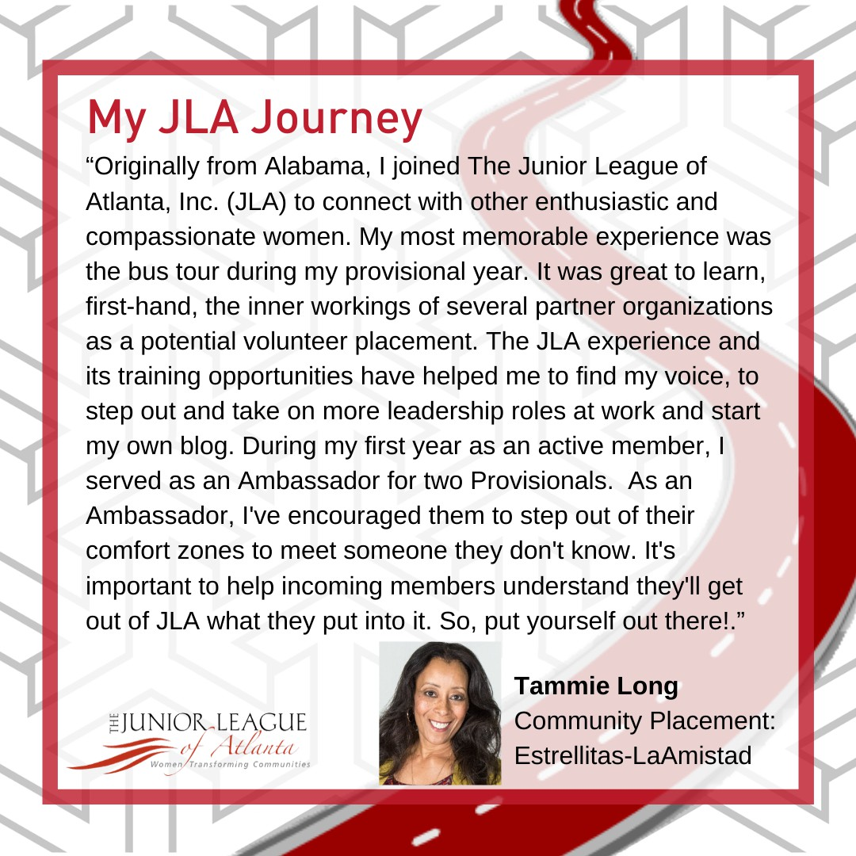

11

12

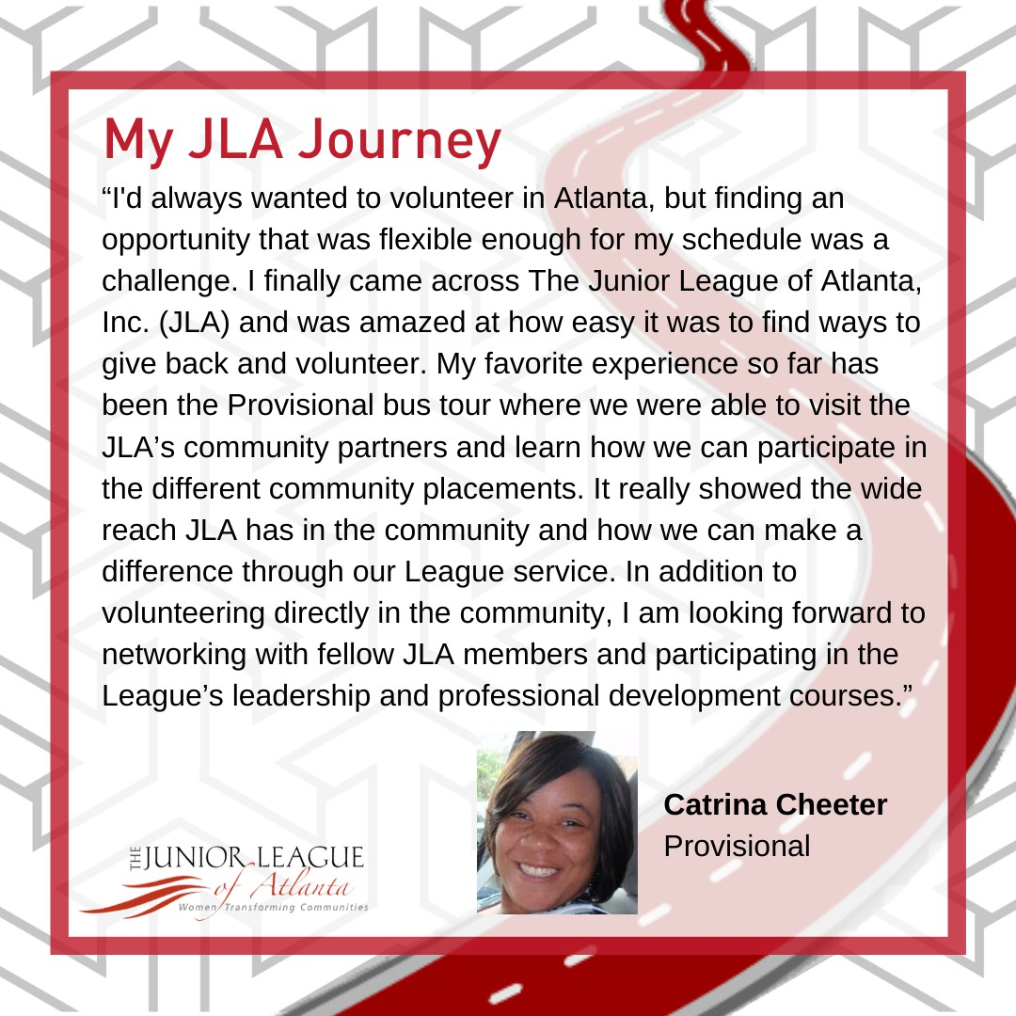

13

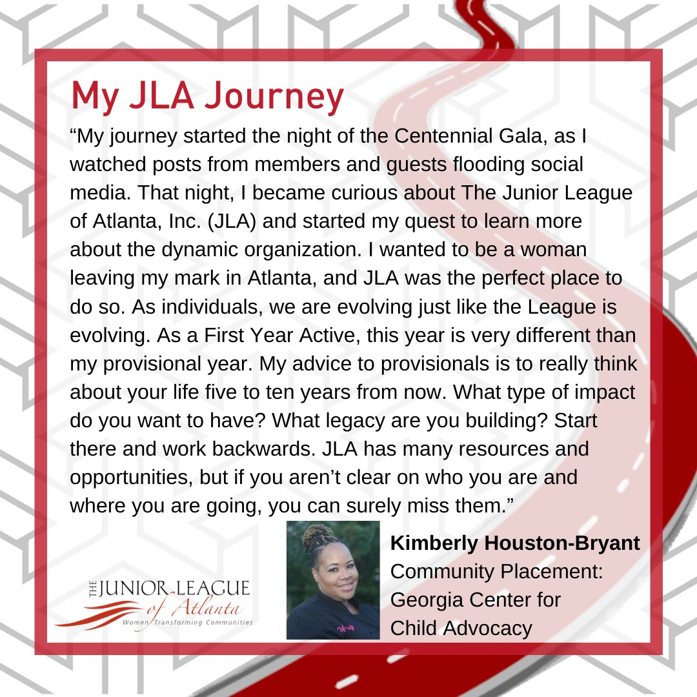

14

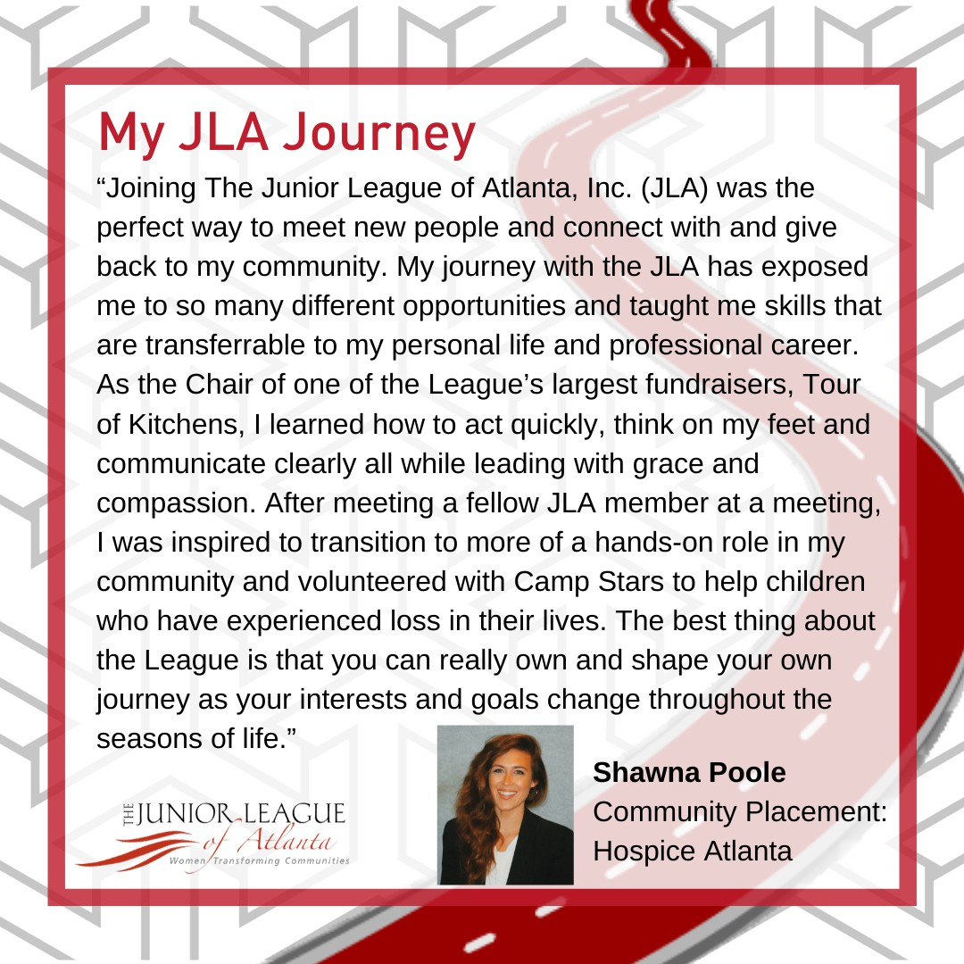

15

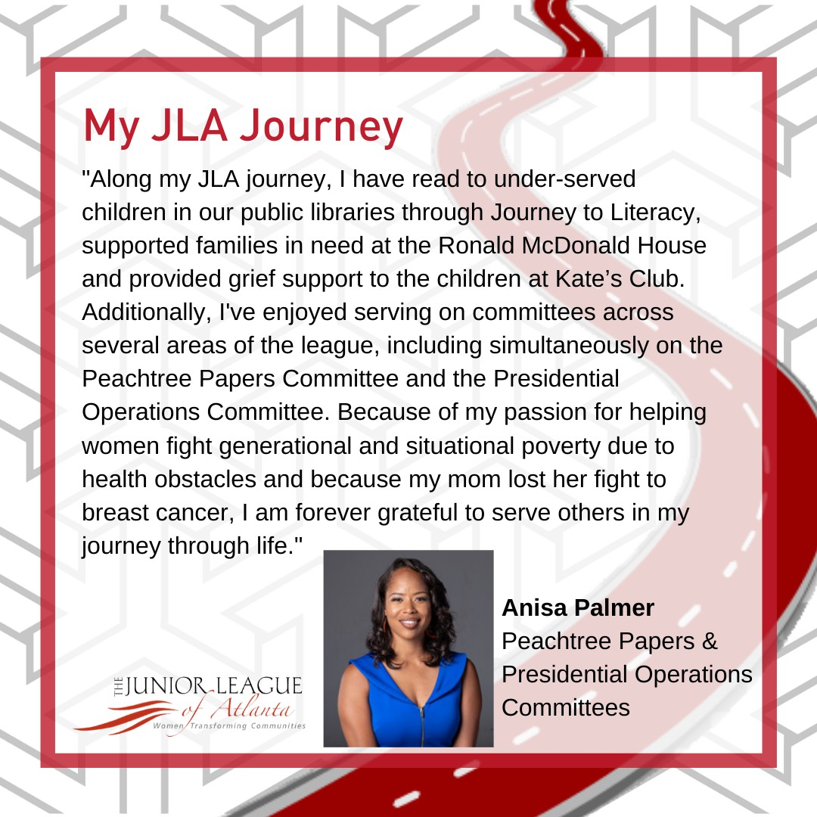

16

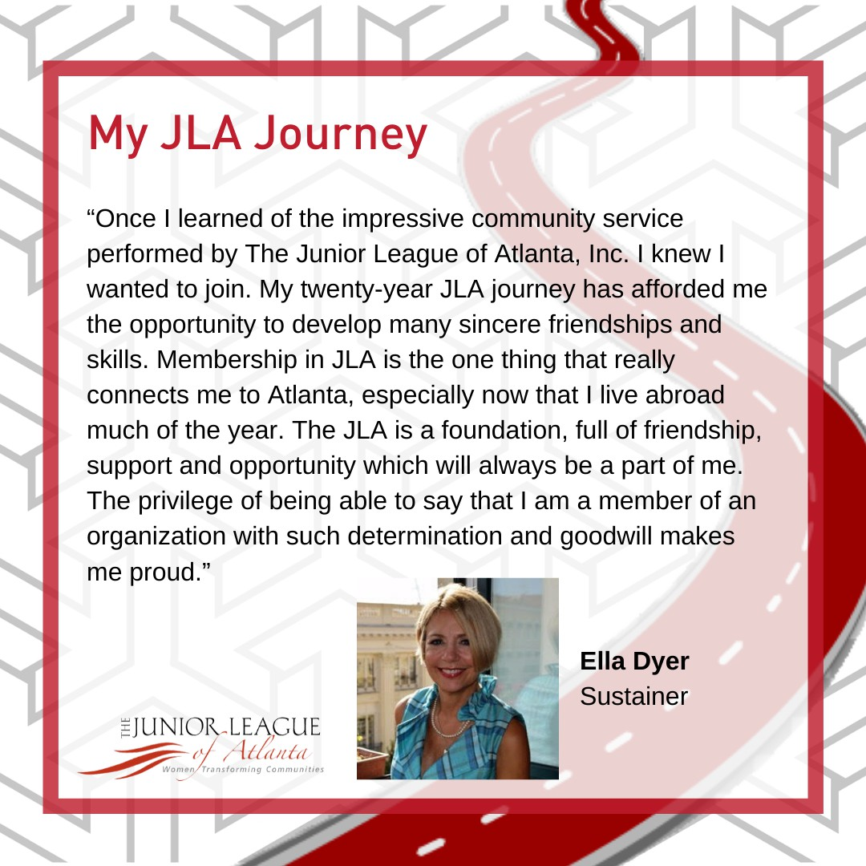

17

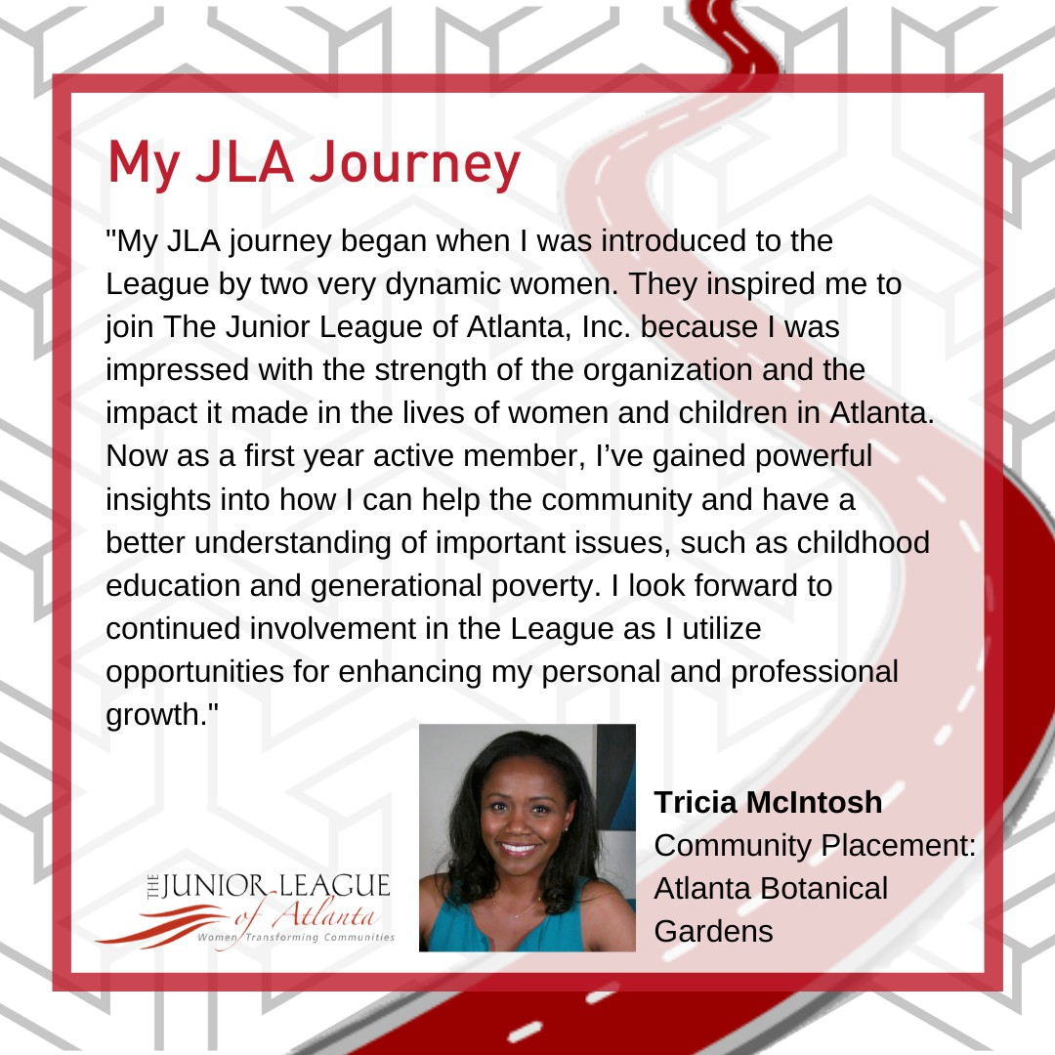

18

