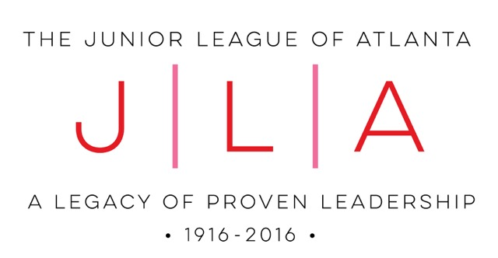

Dear Community Partner,

Your organization is invited to apply for The Junior League of Atlanta, Inc.’s (JLA) 14th Annual Empowerment Award. Typically JLA has selected one agency and one award recipient but we are changing things this year. In 2017, we are selecting three separate agencies alongside three award recipients; one from each of our three platform initiatives: generational poverty, human trafficking and early childhood education. The awards were created to support our vision of assisting and celebrating at-risk women and children who have worked to achieve self-sufficiency. The JLA will recognize the outstanding, exemplary efforts of our Atlanta partners as well as the personal growth of the individual nominees.

Please use the enclosed form to nominate your agency and a woman with whom your organization has worked with for a period of at least six months. The successful application should demonstrate that the individual has worked toward self-sufficiency and developed positive life changes, such as the development of successful job training, money management, stress management and positive personal influences.
For your information, The Junior League of Atlanta, Inc. defines self-sufficiency as having the educational/vocational, emotional and physical health resources, financial management tools, and support systems to adequately provide for basic needs, including affordable housing, transportation, childcare, and nutrition necessary to live independently and become a productive, contributing member of society.
The deadline for receipt of completed applications is Wednesday, April 12, 2017. Additional information and a downloadable application form are available on our website www.jlatlanta.org. (Click on the Community Impact tab, then on Community Awards). To submit your completed application please email it in Word or PDF format to the address above and mail one copy of your paper application with all attachments to:

The Junior League of Atlanta Headquarters
3154 Northside Parkway, NW
Atlanta, GA 30327
Attn: Neha Negandhi, Community Service Awards Chair

The honorees (agency and individual recipient) will be announced in May and presented with the award at the Junior League of Atlanta Annual Membership Meeting on May 9, 2017. The agency and individual recipient will each receive $500 and the individual will also receive some wonderful services and gifts. Please ensure that your individual nominee is willing to have information of her assistance shared with the members of The Junior League of Atlanta, Inc. and the media. We will also invite the selected nominee to briefly speak to our members at the event.

If you have any questions, please contact Neha Negandhi, Community Service Awards Chair, at communityawards@jlatlanta.org or 404-242-2272. We look forward to receiving your application.

Sincerely,

Deanna Anderson Neha Negandhi
2016-2017 President Community Awards Chair

2017 Junior League of Atlanta Empowerment Award Application

AGENCY NOMINEE INFORMATION
Agency Name: ________________________________________________________
Contact: ___________________________________
Contact Phone: _____________________________
Contact Email: ______________________________
Agency Address: ___________________________
___________________________________________

INDIVIDUAL NOMINEE INFORMATION
Nominee Name: __________________________
Nominee Phone: __________________________
Nominee Email: __________________________
Nominee Address: ______________________________________________________
Length of time with your organization: _____________

Criteria for Award
Our mission: The Junior League of Atlanta, Inc., is an organization of women committed to promoting voluntarism, developing the potential of women, and improving the community through the effective action and leadership of trained volunteers. Its purpose is exclusively educational and charitable.
Please thoroughly answer the questions below, explaining why your agency and individual nominee should receive this award. If extra space is needed, please attach additional sheets of paper and include any other documentation that you feel would be useful in our decision. No more than five pages total (not including required attachments) will be reviewed, so please be succinct.
For your information, the Junior League of Atlanta, Inc. defines self-sufficiency as having the educational/vocational, emotional and physical health resources, financial management tools, and support systems to adequately provide for basic needs, including affordable housing, transportation, childcare, and nutrition necessary to live independently and become a productive, contributing member of society.

Provide a copy of your agency’s most recent annual report and 501(c)3 letter.
(Mail or email along with completed application)

Describe your agency’s relationship with the Junior League of Atlanta (e.g., placement for League volunteers, partnered with the League on special projects).

What obstacles to being self-sufficient did the individual nominee face upon coming to your organization? Describe them.

What obstacles has the individual nominee overcome? Name three specific instances where she has overcome adversity.

How has your agency helped the individual nominee overcome some of her obstacles to self-sufficiency? Give three examples.

With the assistance of your organization, she must have developed at least one of the following “empowerment” tools (check or highlight those that apply):
— Positive Mental Health
(e.g., stress management, timely diagnosis and treatment, and/or high self-esteem)
— Life Skills
(e.g., job training, money management, and/or parenting skills)
— Support Systems
(e.g., affordable housing, affordable childcare, and/or positive personal influences)

Describe how the empowerment tool(s) have benefitted her:

What obstacles to self-sufficiency does the individual nominee still face today?

The individual nominee must be working towards achieving self-sufficiency. Describe additional steps that she is taking or will take to achieve self-sufficiency.

How has the individual nominee been a source of empowerment to others in her community? If possible, provide specific examples.

I understand that, if chosen for this award, the Junior League of Atlanta may publicly disclose the information contained in this application. I give my permission for such disclosure.

Nominee Name Nominee Signature

Nominator Name Nominator Signature

